Mini Project 3 Deployment
- Download the demo code from LMS
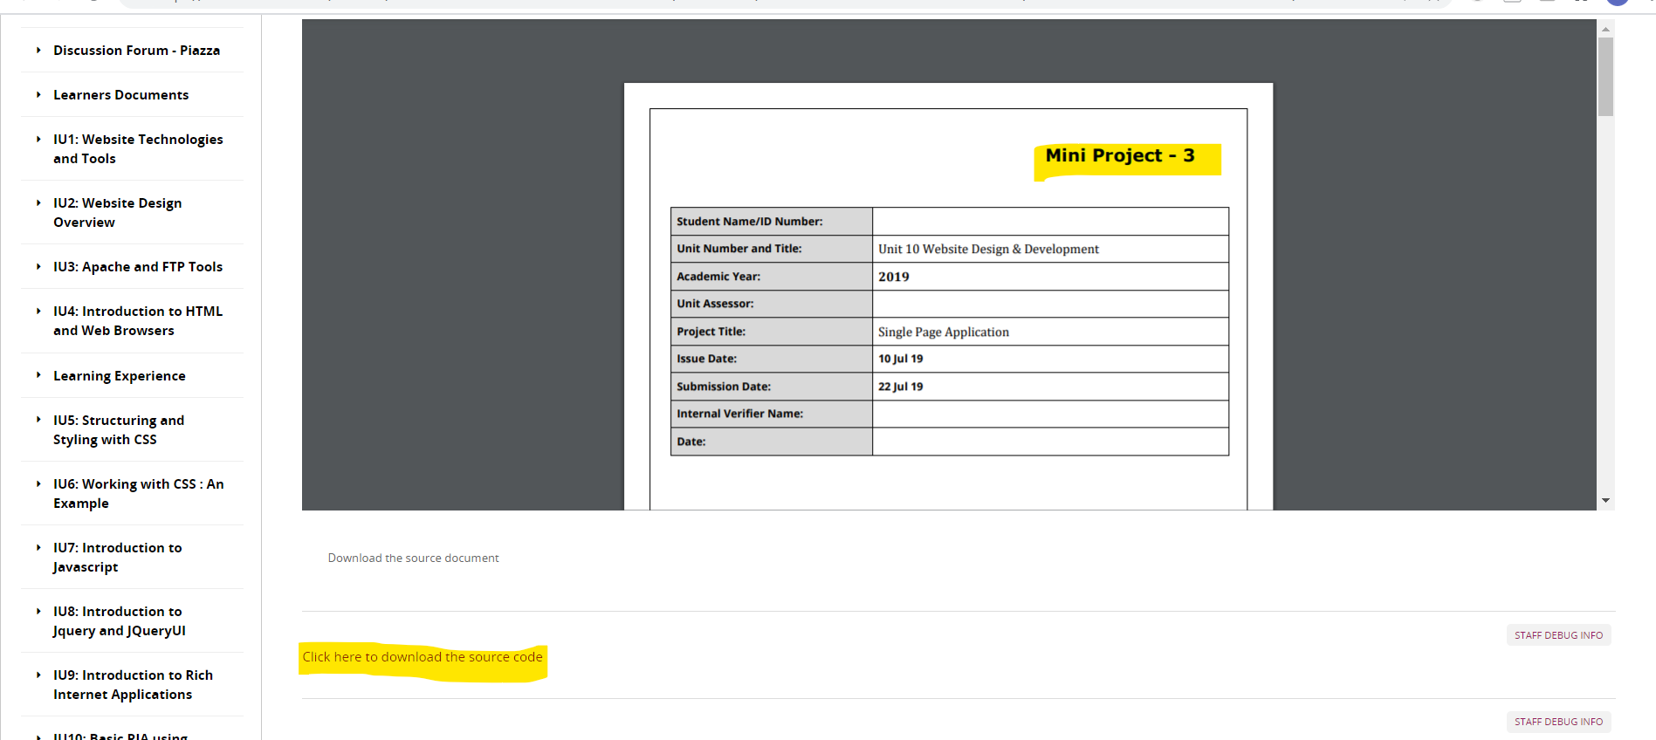

- Extract it
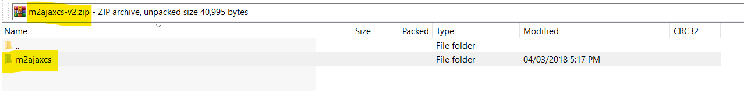
- Deploy under Tomcat
  - Locate tomcat installation folder
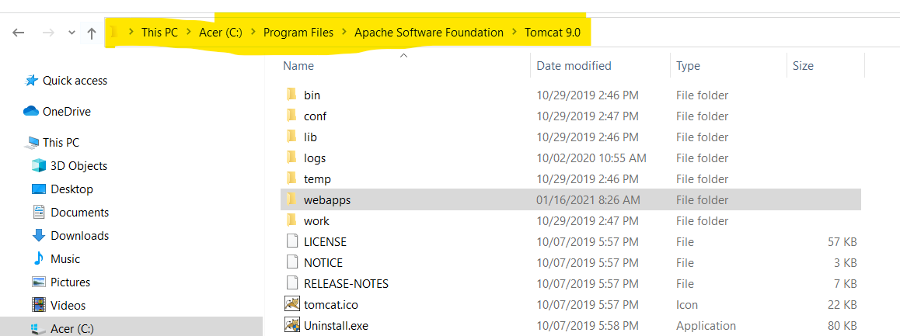
  - Copy the folder m2ajaxcs to Tomcat WebApps folder

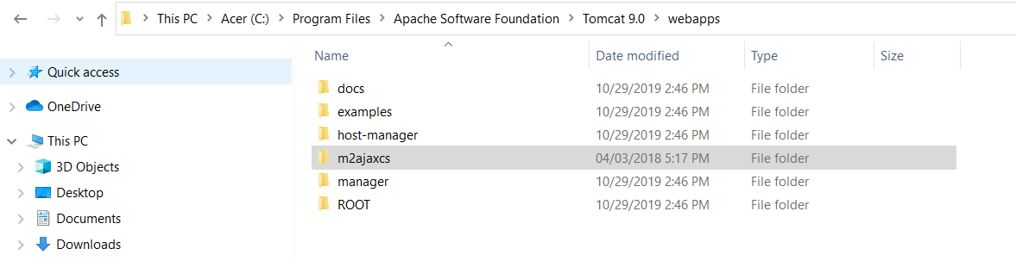

  - Check the files

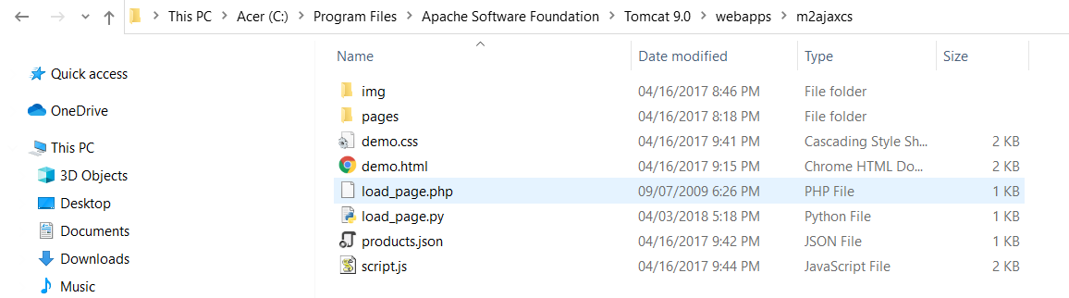
  - Copy load_page.jsp from teams

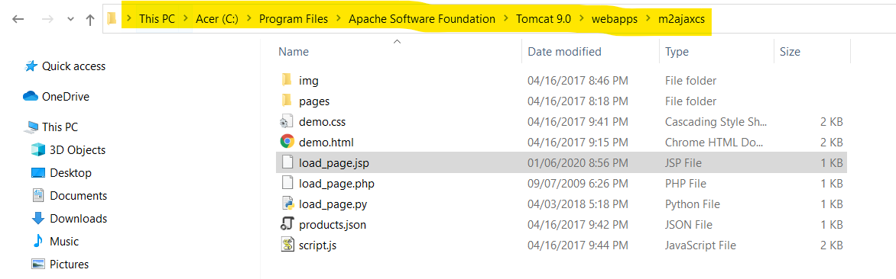

  - Go to services. Ensure your tomcat service is running

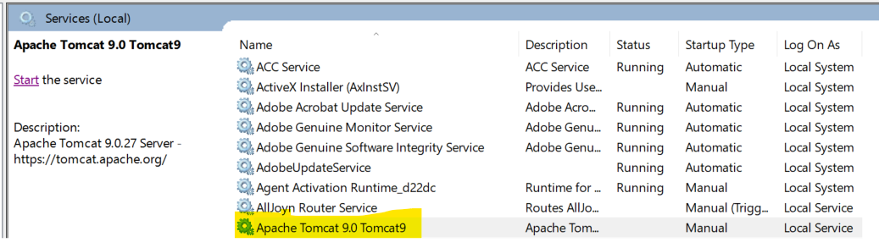

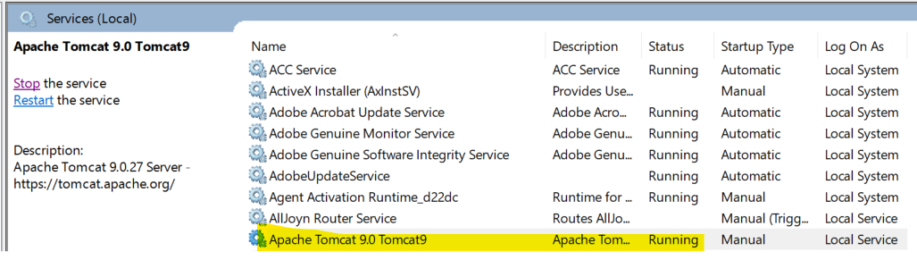

  - Render the page http://localhost:8080/m2ajaxcs/demo.html

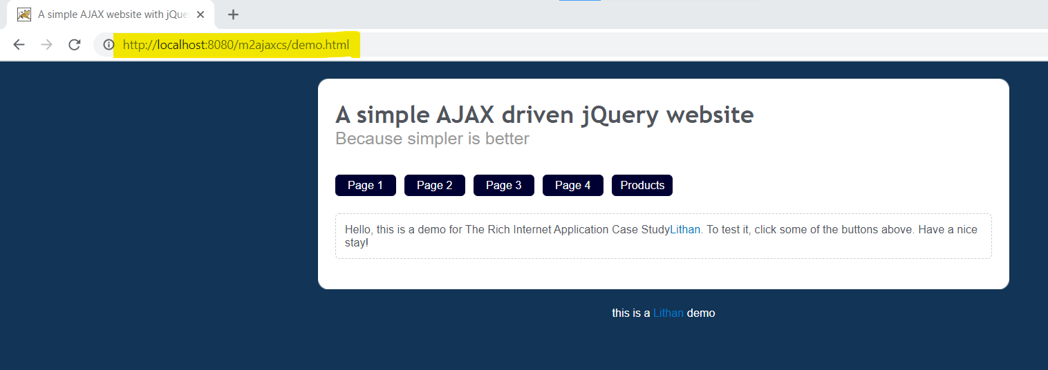

  - Test the backend script
http://localhost:8080/m2ajaxcs/load_page.jsp?page=page_3

